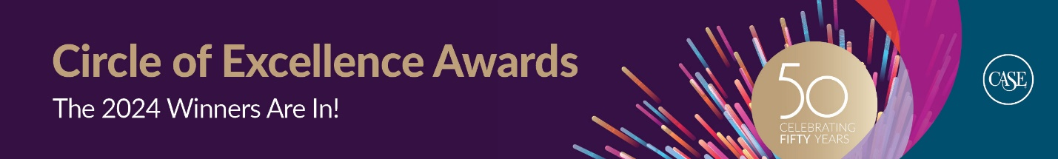
[Institution] Wins 2024 Circle of Excellence Award from the Council for Advancement and Support of Education
CASE’s awards celebrate outstanding achievements in educational advancement
June 26, 2024
Today the Council for Advancement and Support of Education announced the recipients of the 2024 Circle of Excellence Awards.
[Information about your institution and awards]
CASE’s Circle of Excellence Awards are the premier recognition program for educational advancement. These peer-selected and adjudicated awards celebrate colleges, universities, and schools worldwide whose talented staff have advanced their institutions with resourcefulness and ingenuity.
“As we mark CASE’s 50th anniversary this year, we are taking time to celebrate our members across the globe,” says Sue Cunningham, CASE President and CEO. “Examples of their remarkable work are evident throughout the Circle of Excellence Awards. We applaud the achievements and innovation of advancement professionals across all sectors and all regions—work in schools, colleges and universities that advances education and thereby transforms lives and society.”
This year volunteer judges from CASE’s membership selected 486 exemplary entries for bronze, silver, gold, and Grand Gold recognition. Winners are chosen for overall quality, innovation, use of resources, and the impact on the institution or its communities, such as alumni, parents, students, faculty, and staff.
###
About CASE:
The Council for Advancement and Support of Education is the global nonprofit association dedicated to educational advancement—alumni relations, communications, development, marketing, and advancement services—and championing education to transform lives and society.
To fulfill their missions and to meet both individual and societal needs, colleges, universities and independent schools rely on and therefore must foster the goodwill, active involvement, informed advocacy and enduring support of alumni, donors, prospective students, parents, government officials, community leaders, corporate executives, foundation officers, and other external constituencies.
CASE’s membership includes more than 3,000 colleges, universities, and independent elementary and secondary schools in more than 80 countries, making CASE one of the largest nonprofit education associations in the world in terms of institutional membership. CASE serves more than 90,000 advancement professionals at member institutions and has offices in London, UK; Mexico City, Mexico; Singapore; and Washington, D.C., USA. The association produces content, publications, conferences, institutes, and workshops that support educational leaders and advancement professionals in their work to advance education through serving their institutions. To learn more about CASE visit www.case.org.

