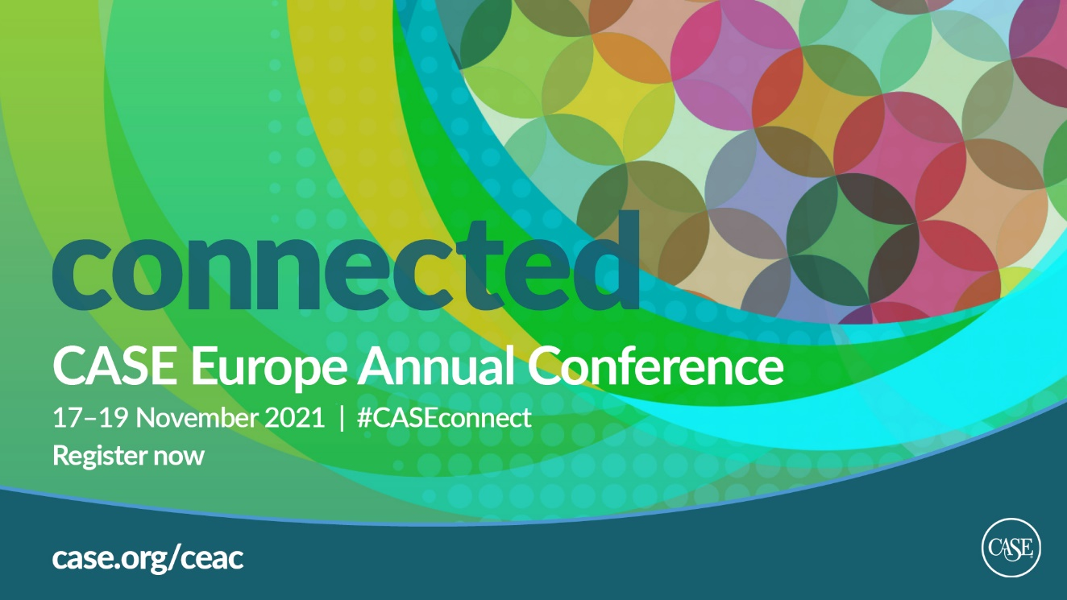

CEAC21 Sponsorship Booking Request

Please mark:
I am an educational partner |  | I am not an educational partner

Company name:

Please indicate your sponsorship package choice:

Platinum
Gold A
Please write which track you want to sponsor. Options: Alumni Relations / Fundraising / Marketing and Communications
Gold B
Please write which plenary you want to sponsor. Options: Mid Plenary or Closing Plenary
Silver
Bronze
Exhibitor

Main contact details for this event (for information, materials, etc.):
Name:
Job title:
Email address:
Telephone:
Once this request is received, CASE will check the item availability and reply with either a confirmation of your booking request and its invoice, or with information about items that are still available.

Should the confirmation of this booking and its invoice be sent to the main contact indicated above?

YES |  |  | NO

If not, please inform where these should be sent:
Name:
Job title:
Email address:
Telephone:

Terms & Conditions
These regulations become a part of the contract between the exhibitor/sponsor and CASE. They have been formulated in the best interest of the exhibitors/sponsors. CASE respectfully requests the full cooperation of the exhibitors/sponsors in observing these rules. All points not covered are subject to the decision of the CASE management.

Sponsor/Exhibitor Cancellation Policy:
In rare circumstances, actions resulting from acts or events beyond CASE’s reasonable control may require the cancellation of a conference.

If CASE cancels or postpones a conference, all paid conference sponsors /exhibitors are eligible for either of the following:
- The paid cost of your sponsorship, exhibit booth and registrations can be credited to the next edition of the same conference. Registrations will be fully transferable to other colleagues at your organization.
- The paid cost of your sponsorship, exhibit booth and registrations can be credited to another sponsorship or exhibitor package at another CASE conference of your choice (expires 12 months from the date of the original conference). Registrations will be fully transferable to other colleagues at your organization. This credit can also be used with CASE advertising opportunities (see the current Media Kit for pricing).
You may also choose to donate all or a portion of your fees to CASE as a charitable gift in support of the professional association that serves your clients and the resources provided to them. CASE will not be responsible for any additional damages, fees or costs associated with a cancellation and recommends that you work with individual vendors (hotel, airline, etc.) directly.
If you choose to cancel a conference sponsorship and/or exhibit opportunity, your request will be considered if made 60 days prior to the start of the specific conference. Any approved refund will result in an administrative fee of 10% in addition to any deposit paid. Requests made inside of 59 days of the start of a specific conference will result in the forfeiture of all monies paid and due for the agreed upon commitment, sponsorship or exhibit opportunity.

Failure to Pay Fees:
All invoices are paid within 30 days of invoice issue date or prior to the start of the conference, whichever comes first. No exhibitor/sponsor will be allowed to participate unless CASE has received payment in full before the start of the event. If an exhibitor or sponsor fails to make payments by the due date, such exhibitor’s and/or sponsor’s rights to exhibit and/or sponsor may be cancelled by CASE without further notice.

This form is not binding unless signed and delivered to CASE, who in return will confirm item availability.

Signature below affirms that:
I have read and agreed to CASE Terms and Conditions of sponsorship (above); and
I have read and agreed with the sponsorship package descriptions.

Signature on behalf of (company name)

Name:
Job title:
Email:
Telephone: |  | Date:
Signature:

