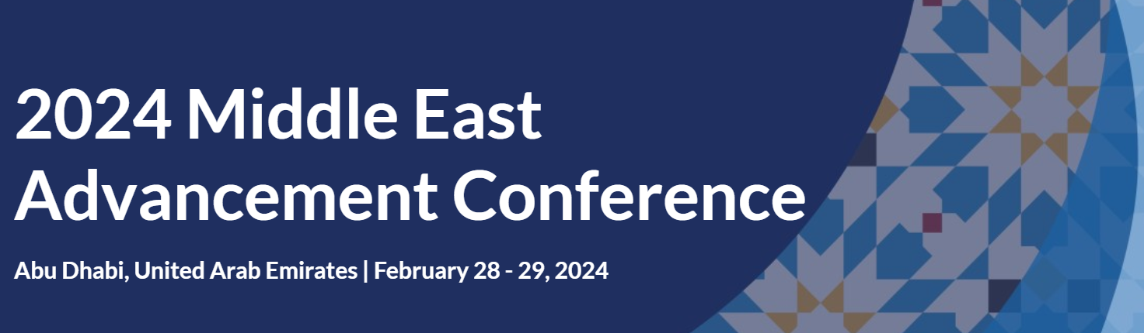

Booking form

Level: GOLD

Company name: (please complete)

Please make sure that you are booking for the desired level.

Gold level benefits:
- 1 x 60min session
- Exhibition space (tabletop)
- Logo in event materials as Gold sponsor
- List of delegates
- Sponsorship of the dinner for participants on evening of the 28 February, Wednesday
- Company materials distributed in seats at dinner (provided by the company)
- 2 delegate passes

Cost:

Please tick box as appropriate – if educational partner or not, and in which currency you would like to be invoiced:

 | Educational Partners |  |  |  | Non-educational partners
GBP | 2,000 |  |  | GBP | 2,400
USD | 2,500 |  |  | USD | 3,000
SGP | 3,360 |  |  | SGP | 4,032

Educational partners: for-profit institutions that are CASE members
Non-educational partners: for-profit institutions that are not CASE members

Terms & Conditions:
These regulations become a part of the contract between the exhibitor/sponsor and CASE. They have been formulated in the best interest of the exhibitors and sponsors. CASE respectfully requests the full cooperation of the exhibitors and sponsors in observing these rules. All points not covered are subject to the decision of the CASE management.

Sponsor/Exhibitor Cancellation Policy:
In rare circumstances, actions resulting from acts or events beyond CASE’s reasonable control may require the cancellation of a conference.
If CASE cancels or postpones a conference, all paid conference sponsors and exhibitors are eligible for either of the following:
- The paid cost of your sponsorship, exhibit booth and registrations can be credited to the next edition of the same conference. Registrations will be fully transferable to other colleagues at your organisation.
- The paid cost of your sponsorship, exhibit booth and registrations can be credited to another sponsorship or exhibitor package at another CASE conference of your choice (expires 12 months from the date of the original conference). Registrations will be fully transferable to other colleagues at your organisation. This credit can also be used with CASE advertising opportunities (see the current Media Kit for pricing).
You may also choose to donate all or a portion of your fees to CASE as a charitable gift in support of the professional association that serves your clients and the resources provided to them.
CASE will not be responsible for any additional damages, fees or costs associated with a cancellation and recommends that you work with individual vendors (hotel, airline, etc.) directly.
If you choose to cancel a conference sponsorship and/or exhibit opportunity, your request will be considered up to 60 days prior to the start of the specific conference. Any approved refund will result in an administrative fee of 10% in addition to any deposit paid. Requests made inside of 59 days of the start of a specific conference will result in the forfeiture of all monies paid and due for the agreed upon commitment, sponsorship or exhibit opportunity.

Failure to Pay Fees:
All invoices are paid within 30 days or prior to the start of the conference, whichever comes first. No exhibitor/sponsor will be allowed to participate unless CASE has received payment in full before the start of the event. If an exhibitor or sponsor fails to make payments by the due date, such exhibitor’s and/or sponsor’s rights to exhibit and/or sponsor may be cancelled by CASE without further notice.

This form is not binding until and unless signed and delivered to CASE, and when so accepted and signed, it shall constitute a binding contract upon the applicant and the applicant’s respective heirs, personal representatives, successors, and assigns, subject to the terms, conditions, rules and regulations.

Please indicate who will be the main contact for arrangements for this conference:
Name:
Job title:
Email:
Telephone:

Signature below confirms the booking request and also affirms that Terms and Conditions form have been read and agreed to.

Name:
Job title:
Date:
Signature:

